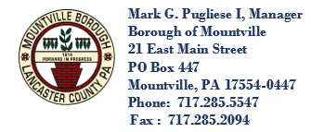

**Mountville Borough**

**21 East Main Street, P. O. Box 447, Mountville, PA 17554-0447**

**Telephone (717) 285-5547 FAX (717) 285-2094**

Right-to-Know Law

*Requesting Mountville Borough Records*

Requests for records must be addressed to the Agency Open Records Officer and can be submitted by email, fax, mail, or in person. The request should be specific and not seek answers to questions. After filing a request, a response will be issued within five (5) business days. (Any and all fees will be in accordance with the fee schedule set by the Pennsylvania Office of Open Records.)

*Mountville Borough’s Open Records Officer is:*

Derrick Millhouse

Mountville Borough Manager

21 East Main Street, PO Box 447

Mountville, PA 17554

Phone: 717-285-5547

Fax: 717-285-2094

manager@mountvilleborough.com

*Filing an Appeal*

When a request is denied or deemed denial, a requester may file an appeal to the Pennsylvania Office of Open Records. The appeal must be filed within 15 business days of the denial or deemed denial date. The appeal must also include the request, agency denial if one exists, and address agency grounds that the request was denied. An appeals officer will determine if the record(s) is subject to public access.

An appeal may be filed to the Office of Open Records via its [Online Appeal Form](https://www.openrecords.pa.gov/Appeals/AppealForm.cfm), email, fax, or in person at:

Office of Open Records

333 Market Street, 16th Floor

Harrisburg, PA 17101-2234

Phone: 717-346-9903

Fax: 717-425-5343

Email: [openrecords@pa.gov](mailto:openrecords@pa.gov)