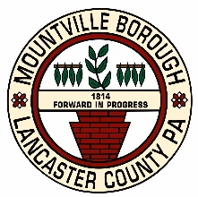
MOUNTVILLE BOROUGH

21 East Main Street, P.O. Box 447, Mountville, PA 17554-0447
Telephone 717-285-5547 FAX 717-285-2094

Application for Garage, Lawn/Yard Sale Permit

Name: ___________________________________________

Address: __________________________________________

Date(s) of sale*: _____________________________________

Items to be sold: ____________________________________

________________________________________________

________________________________________________

I hereby affirm that this sale is not sponsored by a charity or service organization, and that the goods to be sold belong solely to me and/or my household, and that said goods have not been purchased, obtained, or imported from outside the Borough solely for this sale.

____________________________ ___________________
Signature Date

*Permit is valid for two (2) consecutive days. Yard sales are limited to two (2) licensed sales per calendar year per residence.

