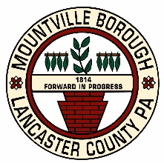
MOUNTVILLE BOROUGH

21 East Main Street, P.O. Box 447, Mountville, PA 17554-0447
Telephone 717-285-5547 FAX 717-285-2094

Mountville Borough Council Reorganization Meeting
AGENDA
6:00 PM Monday, January 2, 2024
at the Mountville Borough Hall, in the large meeting room

- Call to Order (The Honorable Steve Mitchell, Mayor)
- Pledge of Allegiance
- Nomination and Election of President
- Nomination and Election of Vice President
- Nomination and Election of President Pro Tempore
- Appointment of Vacancy Board Chair
- Other Appointments
- Adjournment

